OES Fall Protection Plan

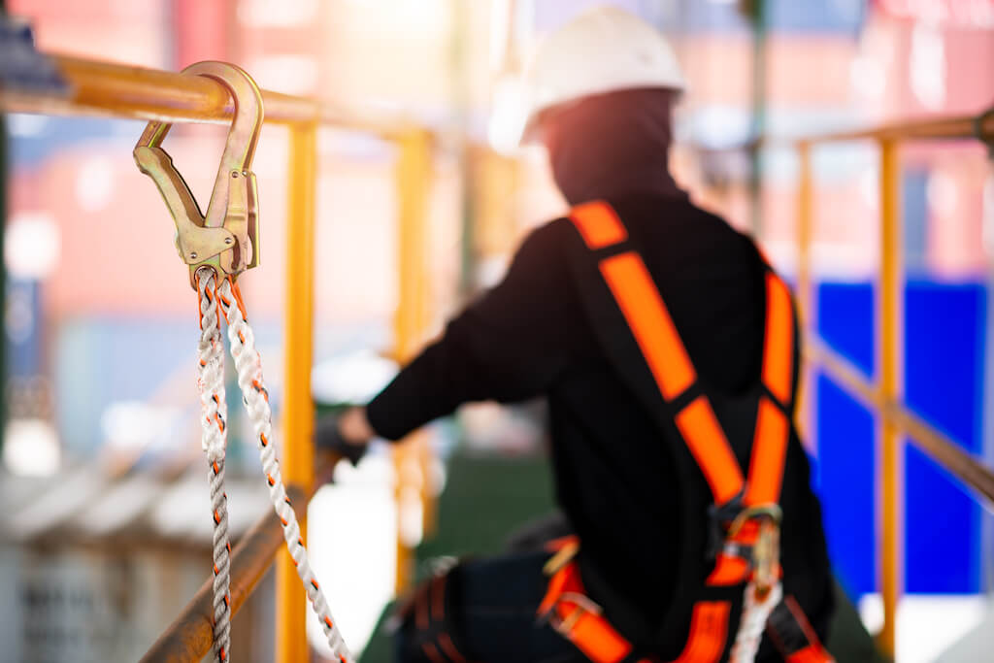

Contents

PURPOSE AND SCOPE 3

DEFINITIONS 3

DUTIES AND RESPONSIBILITIES 7

TRAINING 7

POINT OF CONTACT 8

OES Fall Protection Plan

1.0 Purpose and Scope
The purpose of this written plan is to educate Clemson University (CU) faculty, staff, and students on the importance of fall protection. In accordance with the hierarchy of controls, not all hazards can be eliminated or substituted as necessary. That is when we rely heavily on engineering controls, administrative controls, and personal protective equipment.
The many hazards that can contribute to falls or falling objects are ladders, manhole steps, roofs, stairways, handrails, scaffolds, toe boards, unprotected sides/edges, and many others. This plan, along with the training, serves to educate CU personnel of fall protection, falling object protection, how to prevent them, and what steps are necessary to safely execute the duties associated with them.
2.0 Definitions
Anchorage - a secure point of attachment for equipment such as lifelines, lanyards, deceleration devices, and rope descent systems.
Body belt - (safety belt) a strap with means both for securing it about the waist and for attaching it to a lanyard, lifeline, or deceleration device.
Body harness - straps which may be secured about the employee in a manner that will distribute the fall arrest forces over at least the thighs, pelvis, waist, chest and shoulders with means for attaching it to other components of a personal fall arrest system.
Buckle - any device for holding the body belt or body harness closed around the employee's body.
Connector - a device which is used to couple (connect) parts of the personal fall arrest system and positioning device systems together. It may be an independent component of the system, such as a carabiner, or it may be an integral component of part of the system (such as a buckle or dee-ring sewn into a body belt or body harness, or a snap-hook spliced or sewn to a lanyard or self-retracting lanyard).
Controlled access zone (CAZ) - an area in which certain work (e.g., overhand bricklaying) may take place without the use of guardrail systems, personal fall arrest systems, or safety net systems and access to the zone is controlled.
Dangerous equipment - equipment (such as pickling or galvanizing tanks, degreasing units, machinery, electrical equipment, and other units) which, as a result of form or function, may be hazardous to employees who fall onto or into such equipment.
Deceleration device - any mechanism, such as a rope grab, rip-stitch lanyard, specially-woven lanyard, tearing or deforming lanyards, automatic self-retracting lifelines/lanyards, etc., which serves to dissipate a substantial amount of energy during a fall arrest, or otherwise limit the energy imposed on an employee during fall arrest.
Deceleration distance - the additional vertical distance a falling employee travels, excluding lifeline elongation and free fall distance, before stopping, from the point at which the deceleration device begins to operate. It is measured as the distance between the location of an employee's body belt or body harness attachment point at the moment of activation (at the onset of fall arrest forces) of the deceleration device during a fall, and the location of that attachment point after the employee comes to a full stop.
Equivalent - alternative designs, materials, or methods to protect against a hazard which the employer can demonstrate will provide an equal or greater degree of safety for employees than the methods, materials or designs specified in the standard.
Failure - load refusal, breakage, or separation of component parts. Load refusal is the point where the ultimate strength is exceeded.
Free fall - the act of falling before a personal fall arrest system begins to apply force to arrest the fall.
Free fall distance - the vertical displacement of the fall arrest attachment point on the employee's body belt or body harness between onset of the fall and just before the system begins to apply force to arrest the fall. This distance excludes deceleration distance, and lifeline/lanyard elongation, but includes any deceleration device slide distance or self-retracting lifeline/lanyard extension before they operate and fall arrest forces occur.
Guardrail system - a barrier erected to prevent employees from falling to lower levels.
Hole - a gap or void 2 inches (5.1 cm) or more in its least dimension, in a floor, roof, or other walking/working surface.
Infeasible - that it is impossible to perform the construction work using a conventional fall protection system (i.e., guardrail system, safety net system, or personal fall arrest system) or that it is technologically impossible to use any one of these systems to provide fall protection.
Lanyard - a flexible line of rope, wire rope, or strap which generally has a connector at each end for connecting the body belt or body harness to a deceleration device, lifeline, or anchorage.
Leading edge - the edge of a floor, roof, or formwork for a floor or other walking/working surface (such as the deck) which changes location as additional floor, roof, decking, or formwork sections are placed, formed, or constructed. A leading edge is considered to be an "unprotected side and edge" during periods when it is not actively and continuously under construction.
Lifeline - a component consisting of a flexible line for connection to an anchorage at one end to hang vertically (vertical lifeline), or for connection to anchorages at both ends to stretch horizontally (horizontal lifeline), and which serves as a means for connecting other components of a personal fall arrest system to the anchorage.
Low-slope roof - a roof having a slope less than or equal to 4 in 12 (vertical to horizontal).
Lower levels - those areas or surfaces to which an employee can fall. Such areas or surfaces include, but are not limited to, ground levels, floors, platforms, ramps, runways, excavations, pits, tanks, material, water, equipment, structures, or portions thereof.
Mechanical equipment - all motor or human propelled wheeled equipment used for roofing work, except wheelbarrows and mop carts.
Opening - a gap or void 30 inches (76 cm) or more high and 18 inches (48 cm) or more wide, in a wall or partition, through which employees can fall to a lower level.
Overhand bricklaying and related work - the process of laying bricks and masonry units such that the surface of the wall to be jointed is on the opposite side of the wall from the mason, requiring the mason to lean over the wall to complete the work. Related work includes mason tending and electrical installation incorporated into the brick wall during the overhand bricklaying process.
Personal fall arrest system - a system used to arrest an employee in a fall from a working level. It consists of an anchorage, connectors, a body belt or body harness and may include a lanyard, deceleration device, lifeline, or suitable combinations of these. As of January 1, 1998, the use of a body belt for fall arrest is prohibited.
Positioning device system - a body belt or body harness system rigged to allow an employee to be supported on an elevated vertical surface, such as a wall, and work with both hands free while leaning.
Rope grab - a deceleration device which travels on a lifeline and automatically, by friction, engages the lifeline and locks so as to arrest the fall of an employee. A rope grab usually employs the principle of inertial locking, cam/level locking, or both.
Roof - the exterior surface on the top of a building. This does not include floors or formwork which, because a building has not been completed, temporarily become the top surface of a building.
Roofing work - the hoisting, storage, application, and removal of roofing materials and equipment, including related insulation, sheet metal, and vapor barrier work, but not including the construction of the roof deck.
Safety-monitoring system - a safety system in which a competent person is responsible for recognizing and warning employees of fall hazards.
Self-retracting lifeline/lanyard - a deceleration device containing a drum-wound line which can be slowly extracted from, or retracted onto, the drum under slight tension during normal employee movement, and which, after onset of a fall, automatically locks the drum and arrests the fall.
Snaphook - a connector comprised of a hook-shaped member with a normally closed keeper, or similar arrangement, which may be opened to permit the hook to receive an object and, when released, automatically closes to retain the object. Snaphooks are generally one of two types:
- The locking type with a self-closing, self-locking keeper which remains closed and locked until unlocked and pressed open for connection or disconnection; or
- The non-locking type with a self-closing keeper which remains closed until pressed open for connection or disconnection.
Steep roof - a roof having a slope greater than 4 in 12 (vertical to horizontal).
Toeboard - a low protective barrier that will prevent the fall of materials and equipment to lower levels and provide protection from falls for personnel.
Unprotected sides and edges - any side or edge (except at entrances to points of access) of a walking/working surface, e.g., floor, roof, ramp, or runway where there is no wall or guardrail system at least 39 inches (1.0 m) high.
Walking/working surface - any surface, whether horizontal or vertical on which an employee walks or works, including, but not limited to, floors, roofs, ramps, bridges, runways, formwork and concrete reinforcing steel but not including ladders, vehicles, or trailers, on which employees must be located in order to perform their job duties.
Warning line system - a barrier erected on a roof to warn employees that they are approaching an unprotected roof side or edge, and which designates an area in which roofing work may take place without the use of guardrail, body belt, or safety net systems to protect employees in the area.
Work area - that portion of a walking/working surface where job duties are being performed.

3.0 Duties and Responsibilities
A. Student, staff, employees:
Responsible for the safe use of fall prevention systems and fall protection equipment.
- Inspect fall protection equipment before use and document the inspection.
- Use fall protection correctly when working at heights > than 4’.
- Report all damaged fall protection equipment immediately to the supervisor.
- Before using personal fall arrest system, know how to notify in the event of a rescue is needed – even if it requires a self-rescue.
B. Manager/Supervisor:
Responsible for the fall prevention and protection program, along with the training requirements for it as well.
- Identify the hazards and select the appropriate measures and equipment.
- Give specific and appropriate instructions to prevent exposure to unsafe conditions.
- Must utilize design controls to eliminate the hazard or implement effective measures to prevent employees from falls.
- Ensure the site fall prevention and protection program guidelines are followed by all employees.
- Ensure all employees exposed to fall hazards have been trained in fall prevention and protection.
- Maintain effective fall prevention or protection equipment for employee use.
- Implement effective measures to provide rescue operations if necessary.
- Review and update the site fall prevention and protection program.
- Ensure employees are trained and adhere to all elements of the program.
C. OES:
Is responsible for the interpretation, requirements, audits, and the overall accomplishment of the program, and to serve as a continuing knowledge resource for the campus.
4.0 Training
Requires supervisors and employees involved with or performing work at heights of four feet or greater to be trained by a qualified person prior to the use of fall prevention/prevention equipment. Before any employee is allowed to work in an area that is exposed to a fall hazard, training must be provided for each employee affected. The classroom (online) training module can be found at Fall Protection initial (Online) | SciShield. There is a short knowledge check at the end of the online training to ensure understanding requirements are met. Upon conclusion of the classroom instruction, there is an additional in-person training required which covers the following topics:
Training
- The nature of the fall hazards in the work area and how to recognize them.
- The procedures to be followed in minimizing those hazards.
- The correct procedures for installing, inspecting, operating, maintaining, and disassembling the personal fall protection systems that the employee uses.
- The correct use of personal fall protection systems and equipment such as proper hook-up, anchoring and tie-off techniques, and methods of equipment inspection and storage.
Training Requirements
- Conducted initially and then annually thereafter.
- When fall protection system changes.
- As determined by employee actions.

5.0 Point of Contact
For any questions, comments, or matters pertaining to this written plan, please contact oeshelp@clemson.edu.

